InSpect and AutoSpect GUI
Instruction Manual

Dr. Andrew M. Crawford, PhD

28 October 2024

Version: 0

Introduction
AutoSpec, is a software suite for automatically drift correcting and fitting Laser Ablation – Inductively Coupled Plasma – Time-of-Flight Mass Spectrometry imaging data acquired using the 2R, R, and S2 instruments from TOFWERKS. It provides users a way to not only fit all data in a practical time period, it allows per-pixel resolution spectral investigation of the resulting imaging data in a way not possible with other programs.

General

Available Downloads

Windows
The Windows version of InSpect can be downloaded from GitHub, here: https://github.com/Dr-Crawford/AutoSpect_compiled-InSpect

Linux (currently not available)

Mac (currently not available)

Data Storage and Access:

Data Storage

AutoSpect - Current versions process data from the raw hdf5 files produced by TofPilot. Processed data variables are stored in the native Matlab format. Fitted data is used to update the PeakData structure in the TOFWERKS raw data hdf5 output.

InSpect - The current version of the InSpect software package stores the GUI data to a *.mat file native to MATLAB and also updates the stored data to the *.h5 file from the TOFWERKS instrument.

Data Access

Elemental Mapping

InSpect/AutoSpect
*.mat: The current version of the software can read the *.mat format files save directly from AutoSpect.

TOFWERK
*.h5: The current version of the software reads the *.h5 format directly from the S2, R, and 2R instruments from TOFWERK.

Graphical User Interfaces
There are five main components of the InSpect software suite: InSpect, AutoSpect, RetroSpect, ProSpect, and ReSpect.

InSpect (Main User Interface)
InSpect is the front-end graphical user interface for AutoSpec, RetroSpect, ProSpect, and ReSpect. It allows the user to visualize the per-pixel fitted images collected for the sample, gas-blank, and assigned reference standards.
InSpect, the main user interface, has two main tabs: Drift Correction and Spectral Fitting.

(TAB) Drift Correction
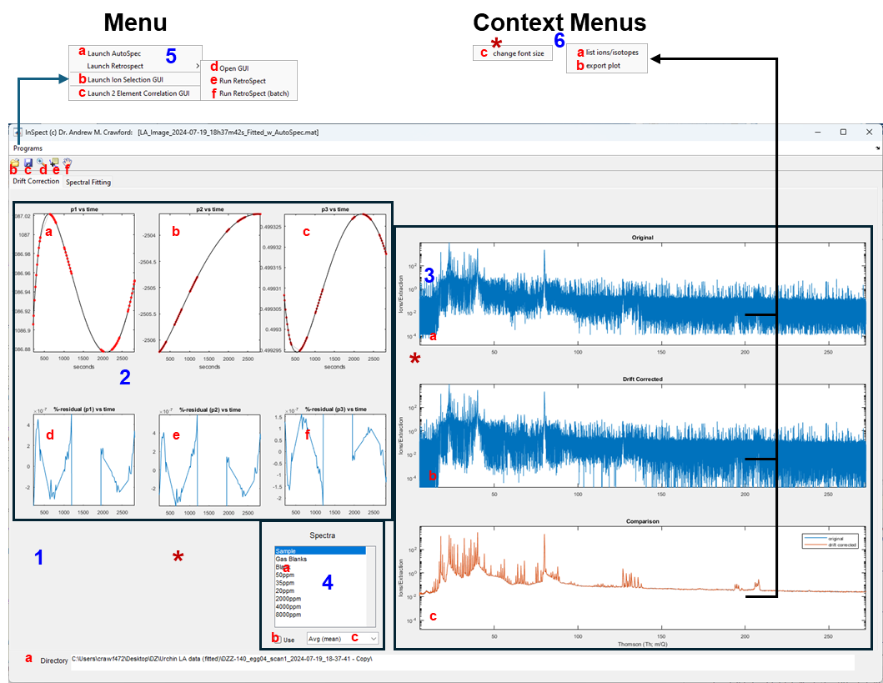
- Main background/panel of GUI
  - Directory where the data for the loaded scan is located
  - Load AutoSpect fitted data or InSpect session.
  - Save the current InSpect session. This amends the AutoSpect fitted file.
  - [toggle] magnifying glass – enables zoom for plots. This deactivates the Context Menus when selected.
  - [toggle] data point indicator – data point information. This deactivates the Context Menus when selected.
  - [toggle] pan – enables panning for plots. This deactivates the Context Menus when selected.
- Drift correction variables – measured and fitted values
  - P₁ drift corrected as a function of time
  - P₂ drift corrected as a function of time
  - P₃ drift corrected as a function of time
  - Residual of P₁ drift corrected as a function of time
  - Residual of P₂ drift corrected as a function of time
  - Residual of P₃ drift corrected as a function of time
- Drift corrected spectra
  - Original uncorrected spectra for all the partitions of the dataset
  - Drift corrected spectra for all the partitions of the dataset
  - Comparison of original and drift corrected spectra averages
- Selecting for different parts of the fitted data
  - Spectra: this allows the user to select the different parts of the file, i.e., Sample, Gas Blanks, individual References.
  - “Use” [checkbox] – Toggles whether or not to use the number of spectra listed in c.
  - [popupmenu] – the number of spectra to display for the part of the scan selected (a). If the user selects “Avg (mean)” then it takes the mean of each partition. 2: this will show the first and last partition of each group. 3: this will show the first, last, and middle partition for the selected group. N: shows the first, last, and N-2 equally spaced partitions from the group.
- Program [Menu]
  - Launch AutoSpect:
  - Launch Ion Selection GUI
  - Launch 2 Element Correlation GUI
  - [Launch Retrospect] Open GUI
  - [Launch Retrospect] Run RetroSpect
  - [Launch Retrospect] Run RetroSpect (batch)
- Context Menus
  - List ions/isotopes: this allows the user to draw a rectangle around an energy region and then lists the isotopes in the current lookup table available for fitting.
  - export plot: exports the plot so that the user can save it as an image.
  - change font size: This changes the font size for the GUI

(TAB) Spectral Fitting
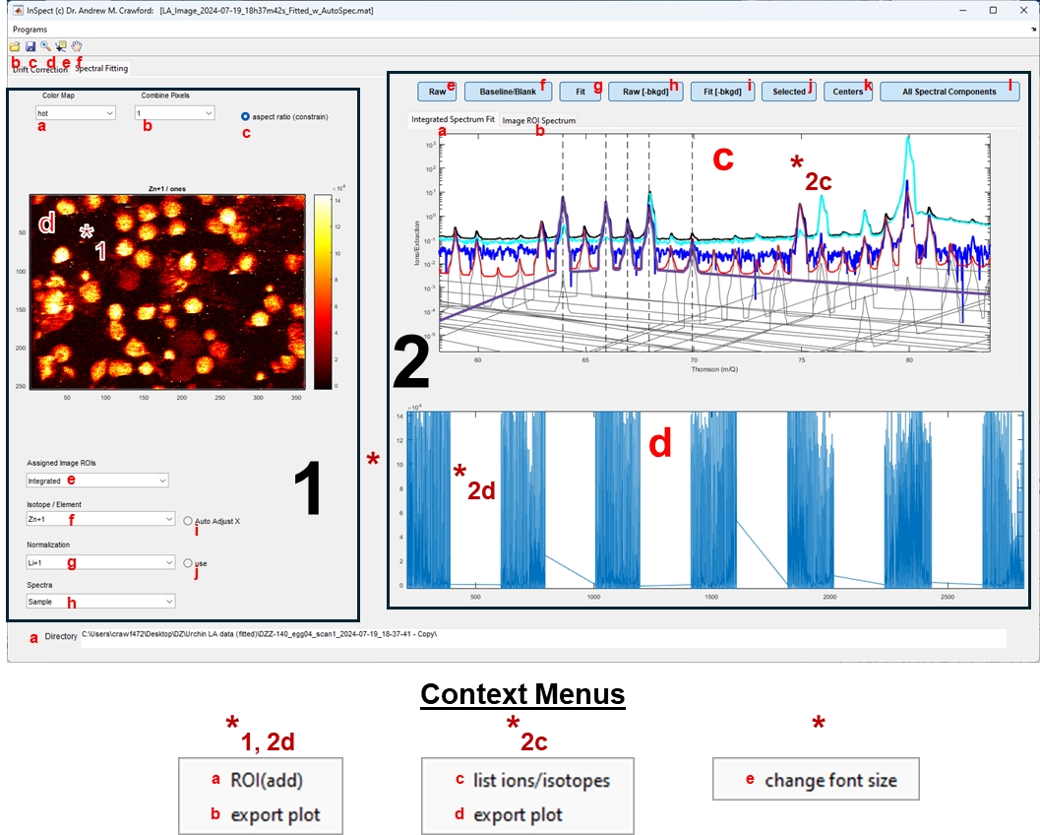

Supporting GUIs:

AutoSpect
AutoSpect is a program for the semiautomatic processing and fitting of LA-ICP-TOFMS imaging data acquired using the 2R, R, and S2 instruments from TOFWERKS. AutoSpec automatically corrects for time dependent peak drift and Thomson recalibration.

RetroSpect

RetroSpect: Tailing Parameters
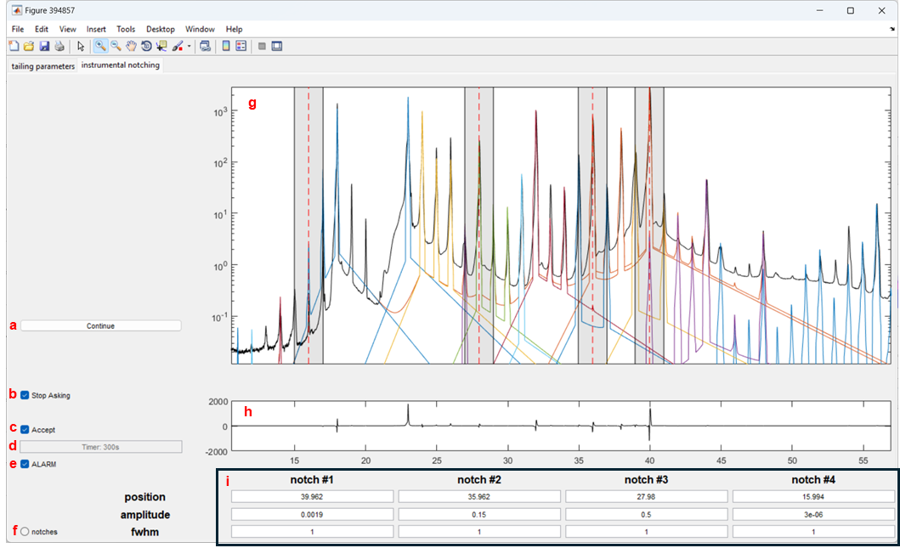

RetroSpect: Instrumental Notching
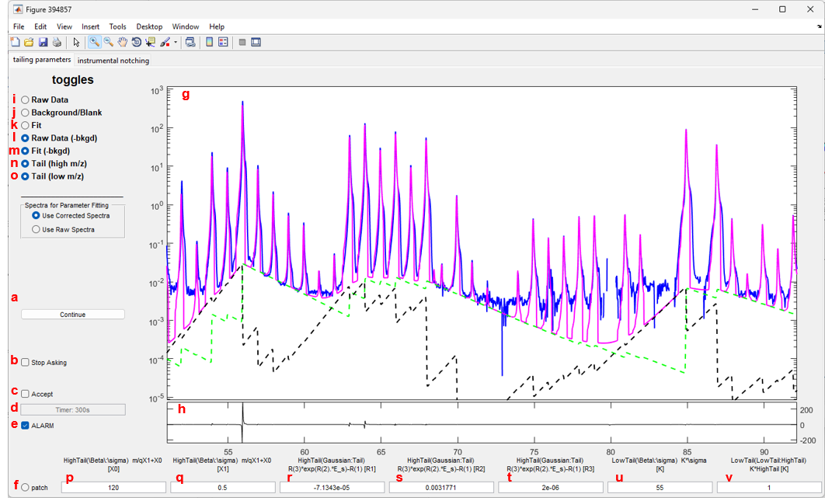

Isotope Selection GUI

Isotope Table (TAB)
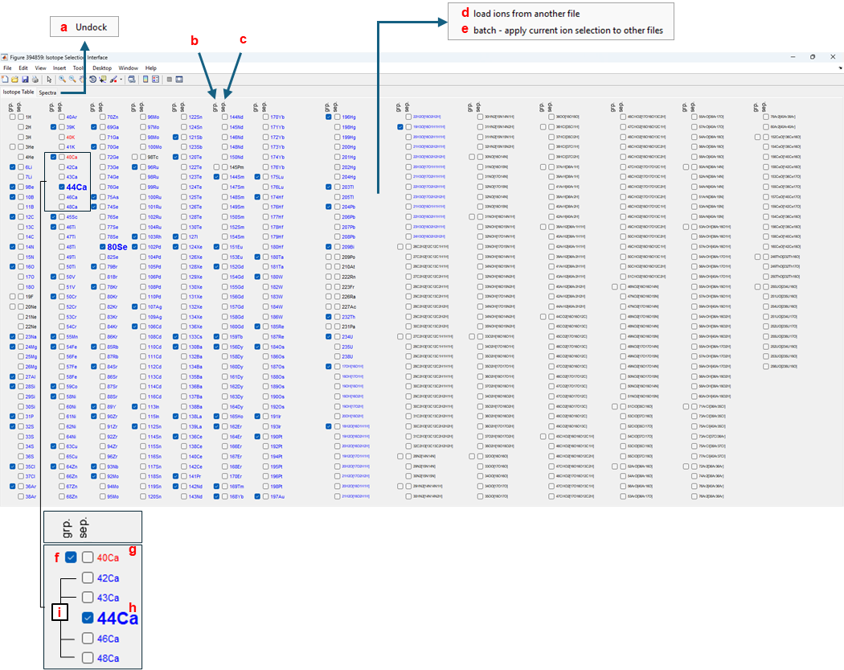

Spectra (TAB)
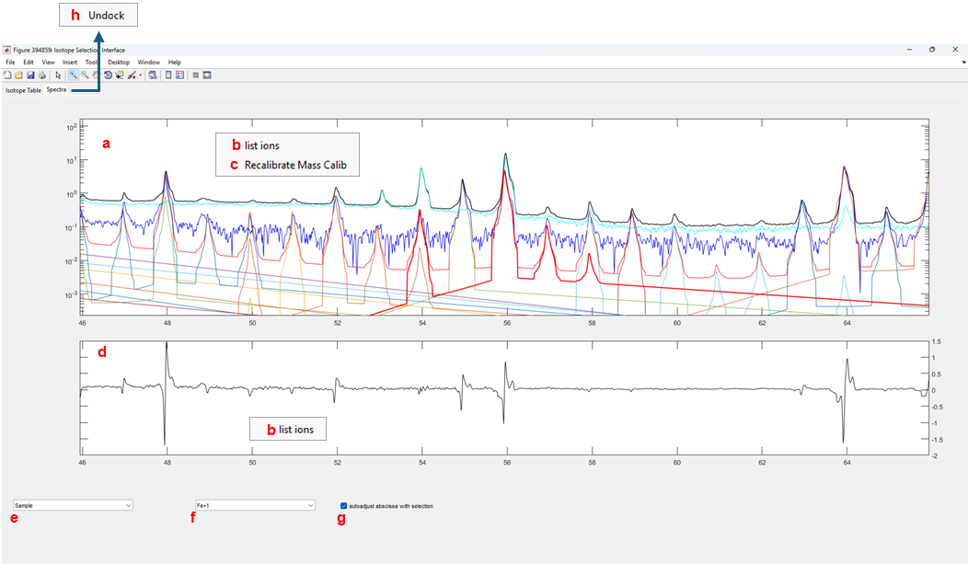

Key Press
delete
rightarrow
leftarrow
shift
space

ProSpect

ReSpect

Processing Data

Loading a dataset

Fitting Datasets

Changing isotope selection

Data diagnostics

